## DATA MODEL:

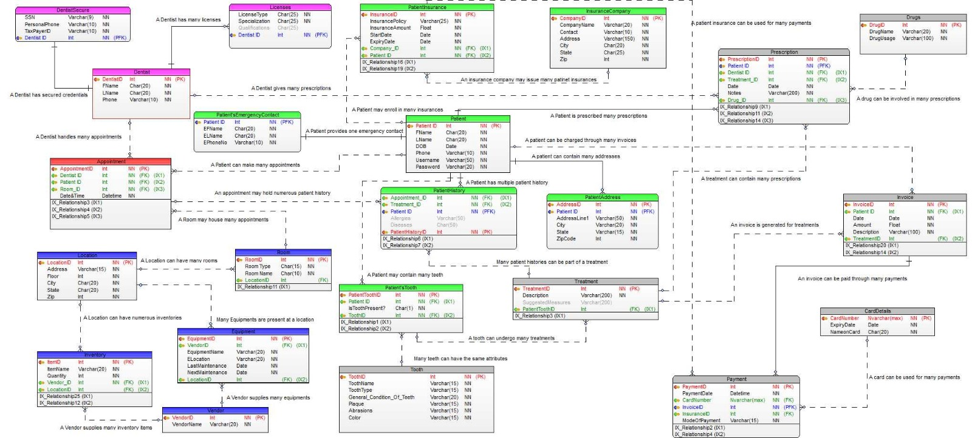

Fig: Data Model for Dental clinic database Model

# HIGH LEVEL DIAGRAM

Fig: High-Level Diagram for Dental clinic database Model